Hamza Salahuddin
24k-3065
Lab-05
Q3
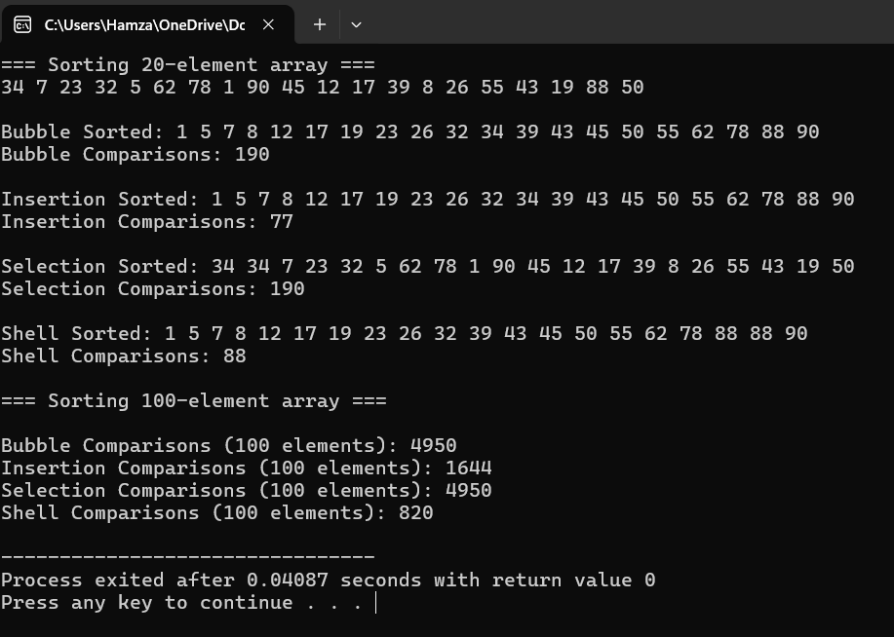
#include<iostream>
using namespace std;

int bubbleSort(int arr[],int n){
int comp=0;
for(int i=0;i<n-1;i++){
for(int j=0;j<n-i-1;j++){
comp++;
if (arr[j]>arr[j+1]){
swap(arr[j],arr[j+1]);
}
}
}
return comp;
}
int selectionSort(int arr[],int n){
int comp=0;
for(int i=0;i<n-1;i++){
int minIndex=i;
int j;
for(j=i+1;j<n;j++){
comp++;
if(arr[i]<arr[minIndex]){
minIndex=j;

}
}
swap(arr[j],arr[minIndex]);
}
return comp;
}

int insertionSort(int arr[],int n){
int comp=0;
for(int i=1;i<n;i++){
int key=arr[i];
int j=i-1;
while(j>=0 && arr[j]>key){
comp++;
if(arr[j]>key){
arr[j+1]=arr[j];
j--;
}else{
break;
}
}
arr[j+1]=key;
}
return comp;
}
int shellSort(int arr[],int n){
int comp=0;
for(int gap=n/2;gap>0;gap/=2){
for(int i=gap;i<n;i++){
int temp= arr[i];
int j=i;
while(j>=gap){
comp++;
if(arr[j-gap]>temp){
arr[j]=arr[j-gap];
j-=gap;
}
else{
break;
}
}
arr[j]=temp;
}
}
return comp;
}
void printArray(int arr[], int n) {
for(int i=0; i<n; i++)
cout << arr[i] << " ";
cout << endl;
}
int main(){
const int smallSize = 20;
int arrSmall[smallSize] = {34, 7, 23, 32, 5, 62, 78, 1, 90, 45, 12, 17, 39, 8, 26, 55, 43, 19, 88, 50};

cout << "=== Sorting 20-element array ===" << endl;
printArray(arrSmall, smallSize);

int arrBubble[smallSize], arrInsertion[smallSize], arrSelection[smallSize], arrShell[smallSize];
for(int i=0; i<smallSize; i++) {
arrBubble[i] = arrSmall[i];
arrInsertion[i] = arrSmall[i];
arrSelection[i] = arrSmall[i];
arrShell[i] = arrSmall[i];
}
int bubbleComp = bubbleSort(arrBubble, smallSize);
cout << "\nBubble Sorted: ";
printArray(arrBubble, smallSize);
cout << "Bubble Comparisons: " << bubbleComp << endl;

int insertionComp = insertionSort(arrInsertion, smallSize);
cout << "\nInsertion Sorted: ";
printArray(arrInsertion, smallSize);
cout << "Insertion Comparisons: " << insertionComp << endl;

int selectionComp = selectionSort(arrSelection, smallSize);
cout << "\nSelection Sorted: ";
printArray(arrSelection, smallSize);
cout << "Selection Comparisons: " << selectionComp << endl;

int shellComp = shellSort(arrShell, smallSize);
cout << "\nShell Sorted: ";
printArray(arrShell, smallSize);
cout << "Shell Comparisons: " << shellComp << endl;

const int largeSize = 100;
int arrLarge[largeSize] = {
34,7,23,32,5,62,78,1,90,45,12,17,39,8,26,55,43,19,88,50,
66,11,27,70,49,2,82,31,14,60,73,36,6,95,84,29,41,18,54,21,
13,80,24,9,3,92,56,33,47,22,10,40,77,30,4,61,86,51,28,67,
35,48,25,16,75,37,59,20,38,53,44,65,79,46,15,85,72,64,42,52,
57,74,63,71,58,68,81,83,87,69,76,89,94,96,91,98,99,97,100, 0
};

cout << "\n=== Sorting 100-element array ===" << endl;

int arrB[largeSize], arrI[largeSize], arrS[largeSize], arrSh[largeSize];
for(int i=0; i<largeSize; i++) {
arrB[i] = arrLarge[i];
arrI[i] = arrLarge[i];
arrS[i] = arrLarge[i];
arrSh[i] = arrLarge[i];
}

bubbleComp = bubbleSort(arrB, largeSize);
insertionComp = insertionSort(arrI, largeSize);
selectionComp = selectionSort(arrS, largeSize);
shellComp = shellSort(arrSh, largeSize);

cout << "\nBubble Comparisons (100 elements): " << bubbleComp << endl;
cout << "Insertion Comparisons (100 elements): " << insertionComp << endl;
cout << "Selection Comparisons (100 elements): " << selectionComp << endl;
cout << "Shell Comparisons (100 elements): " << shellComp << endl;

return 0;

}
Q4
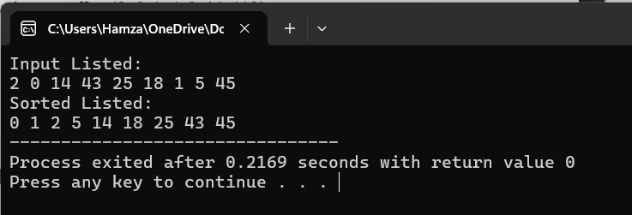
#include<iostream>
using namespace std;

int BubbleSort(int arr[],int n){
for(int i=1;i<n-1;i++){
for(int j=0;j<n-i-1;j++){
if(arr[j]>arr[j+1]){
swap(arr[j],arr[j+1]);
}
}
}
}
int main(){
int arr[]= {2,0,14,43,25,18,1,5,45};
int n=sizeof(arr)/sizeof(arr[0]);

cout<<"Input Listed: "<<endl;
for(int i=0;i<n;i++){
cout<<arr[i]<<" ";
}
BubbleSort(arr, n);

cout<<"\nSorted Listed: "<<endl;
for(int i=0;i<n;i++){
cout<<arr[i]<<" ";
}

}

Q5
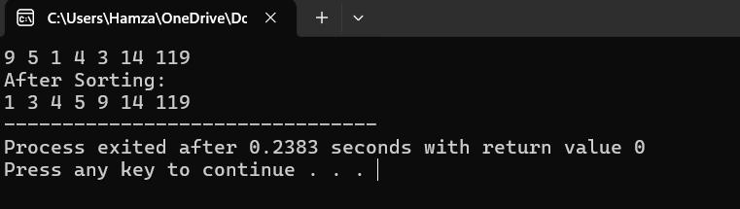#include<iostream>
using namespace std;

int InsertSort(int arr[],int n){
for(int i=1;i<n;i++){
int key=arr[i];
int j=i-1;
while(j>=0 && j[arr]>key){
arr[j+1]=arr[j];
j--;
}
arr[j+1]=key;
}
}
int main(){
int myarr[]={9,5,1,4,3,14,119};
int n =sizeof(myarr)/sizeof(myarr[0]);
for(int i=0;i<n;i++){
cout<<myarr[i]<<" ";
}
InsertSort(myarr,n);
cout<<endl;
cout<<"After Sorting: "<<endl;
for(int i=0;i<n;i++){
cout<<myarr[i]<<" ";
}
}
Q6
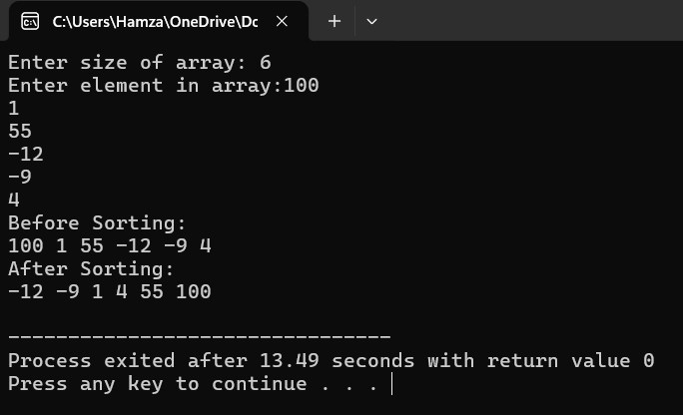
#include<iostream>
using namespace std;

void ShellSort(int arr[],int n){
for(int gap=n/2;gap>0;gap/=2){
for (int i=gap;i<n;i++){
int temp=arr[i];
int j;
for(j=i;j>=gap && arr[j-gap]>temp;j-=gap){
arr[j]=arr[j-gap];
}
arr[j]=temp;
}
}
}
int main(){
int n;
cout<<"Enter size of array: ";
cin>>n;
int arr[n];
cout<<"Enter element in array:";
for(int i=0;i<n;i++){
cin>>arr[i];
}

cout<<"Before Sorting: "<<endl;
for(int i=0;i<n;i++){
cout<<arr[i]<<" ";
}
cout<<endl;
ShellSort(arr,n);
cout<<"After Sorting: "<<endl;
for(int i=0;i<n;i++){
cout<<arr[i]<<" ";
}
cout<<endl;
}
Q7
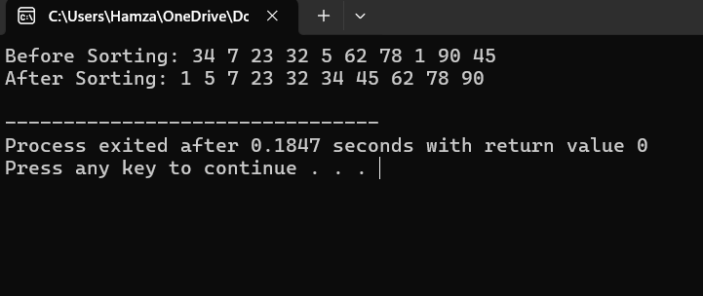#include<iostream>
using namespace std;
int getNextGap(int gap){
gap=(gap*10)/13;
return (gap<1)?1:gap;
}
void Combsort(int arr[],int n){
int gap=n;
bool swapped=true;
while(gap!=1 || swapped){
gap=getNextGap(gap);
swapped=false;
for(int i=0;i<n-gap;i++){
if(arr[i]>arr[i+gap]){
swap(arr[i],arr[i+gap]);
swapped=true;
}
}
}
}
int main() {
int arr[] = {34, 7, 23, 32, 5, 62, 78, 1, 90, 45};
int n = sizeof(arr) / sizeof(arr[0]);

cout <<"Before Sorting: ";
for (int i=0;i<n;i++)
cout<<arr[i]<<" ";
cout<<endl;

Combsort(arr, n);

cout <<"After Sorting: ";
for (int i=0;i<n;i++)
cout<<arr[i]<<" ";
cout<<endl;
}

Q8
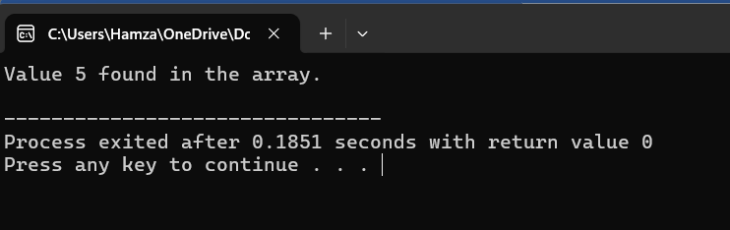
#include<iostream>
using namespace std;

int LinearSearch(int arr[],int n, int key){
for(int i=0; i<n;i++){
if(arr[i]==key){
return i;
}
return -1;
}
}
int main(){
int arr[] = {3, 8, 5, 12, 7, 9};
int n = sizeof(arr) / sizeof(arr[0]);
int key = 5;
int index = LinearSearch(arr, n, key);

if (index!=-1) {
cout<<"Value "<<key<<"not found at index"<<index<<endl;
} else {
cout<<"Value "<<key<<" found in the array."<<endl;
}
return 0;
}

Q9
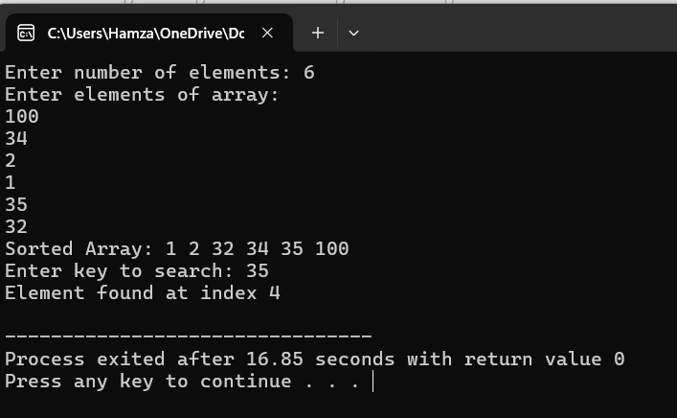
#include <iostream>
using namespace std;

int i = 0;

int interpolationSearch(int arr[], int n, int key) {
int low = 0, high = n - 1;
while (low <= high && key >= arr[low] && key <= arr[high]) {
if (low == high) {
if (arr[low] == key) return low;
return -1;
}
int pos = low + (((double)(high - low) / (arr[high] - arr[low])) * (key - arr[low]));
if (arr[pos] == key) return pos;
if (arr[pos] < key) low = pos + 1;
else high = pos - 1;
}
return -1;
}

void sortArray(int arr[], int n) {
for (i = 0; i < n - 1; i++) {
for (int j = 0; j < n - i - 1; j++) {
if (arr[j] > arr[j + 1]) {
int temp = arr[j];
arr[j] = arr[j + 1];
arr[j + 1] = temp;
}
}
}
}

int main() {
int n,key;
cout<<"Enter number of elements: ";
cin>>n;
int arr[n];
cout<<"Enter elements of array:\n";
for (i=0;i<n;i++) {
cin >> arr[i];
}
sortArray(arr, n);

cout << "Sorted Array: ";
for (i=0;i<n;i++){
cout << arr[i] << " ";
}
cout<<endl;

cout<<"Enter key to search: ";
cin>>key;

int index=interpolationSearch(arr, n, key);

if (index!=-1) {
cout << "Element found at index " << index << endl;
}
else{
cout << "Element not found\n";
}
return 0;
}
Q10
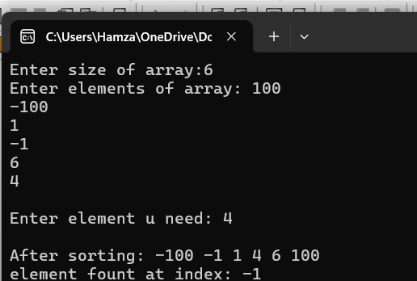
#include<iostream>
using namespace std;

int binarysearch(int arr[],int n,int key){
int low=0 , high=n-1;
while(low<=high){
int mid=low+(high-low)/2;
if(arr[mid]==key){
return mid;
}
else if(arr[mid]<key){
low=mid+1;
}
else{
high=mid-1;
}
}
return -1;
}

void BubbleSort(int arr[],int n){
bool swapped=true;
for(int i=0;i<n-1;i++){
swapped =true;
for(int j=0;j<n-i-1;j++){
if(arr[j]>arr[j+1]){
swap(arr[j],arr[j+1]);
swapped=true;
}
}
if(!swapped) break;
}
}

int main(){
int n,key;
cout<<"Enter size of array:";
cin>>n;
int arr[n];
cout<<"Enter elements of array: ";
for(int i=0;i<n;i++){
cin>>arr[i];
}
cout<<endl;
cout<<"Enter element u need: ";
cin>>key;
cout<<endl;
BubbleSort(arr,n);
int result=binarysearch(arr,n,key);

cout<<"After sorting: ";
for(int i=0;i<n;i++){
cout<<arr[i]<<" ";
}
cout<<endl;
if(result!=-1){
cout<<"element fount at index: "<<result<<endl;
}
else {
cout<<"not found!"<<endl;
}
return 0;
}

